**Article Evaluation: Time and the Twin Paradox NAME_______________________**

**Author: Ronald C. Lasky Publication: Scientific American Vol 23, No 4. Autumn 2014**

*Allowed – Annotated copy of article, formula sheet, scientific calculator (36 Marks, 60 Minutes)*

*Paradox – A seemingly absurd or contradictory statement or proposition which when investigated may prove to be absolutely true.*

1 Special relativity states that there is no absolute motion. How does this create a paradox in the travelling twin being younger scenario?

*The paradox is that while the twin on Earth sees time as slowing for the travelling twin, the travelling twin sees time as slowing for the twin on Earth. ✓*

*(1 Mark)*

2. The article states that it would take about 100 days for the spacecraft to get to a speed of 0.6c, but that an electron could be accelerated to such a speed in a fraction of a second. Give two reasons why this would be the case:

i) *The travelling twin could not withstand greater acceleration for long. ✓*

ii) *Electrons have very little mass and hence require less force to accelerate. ✓*

*(2 Marks)*

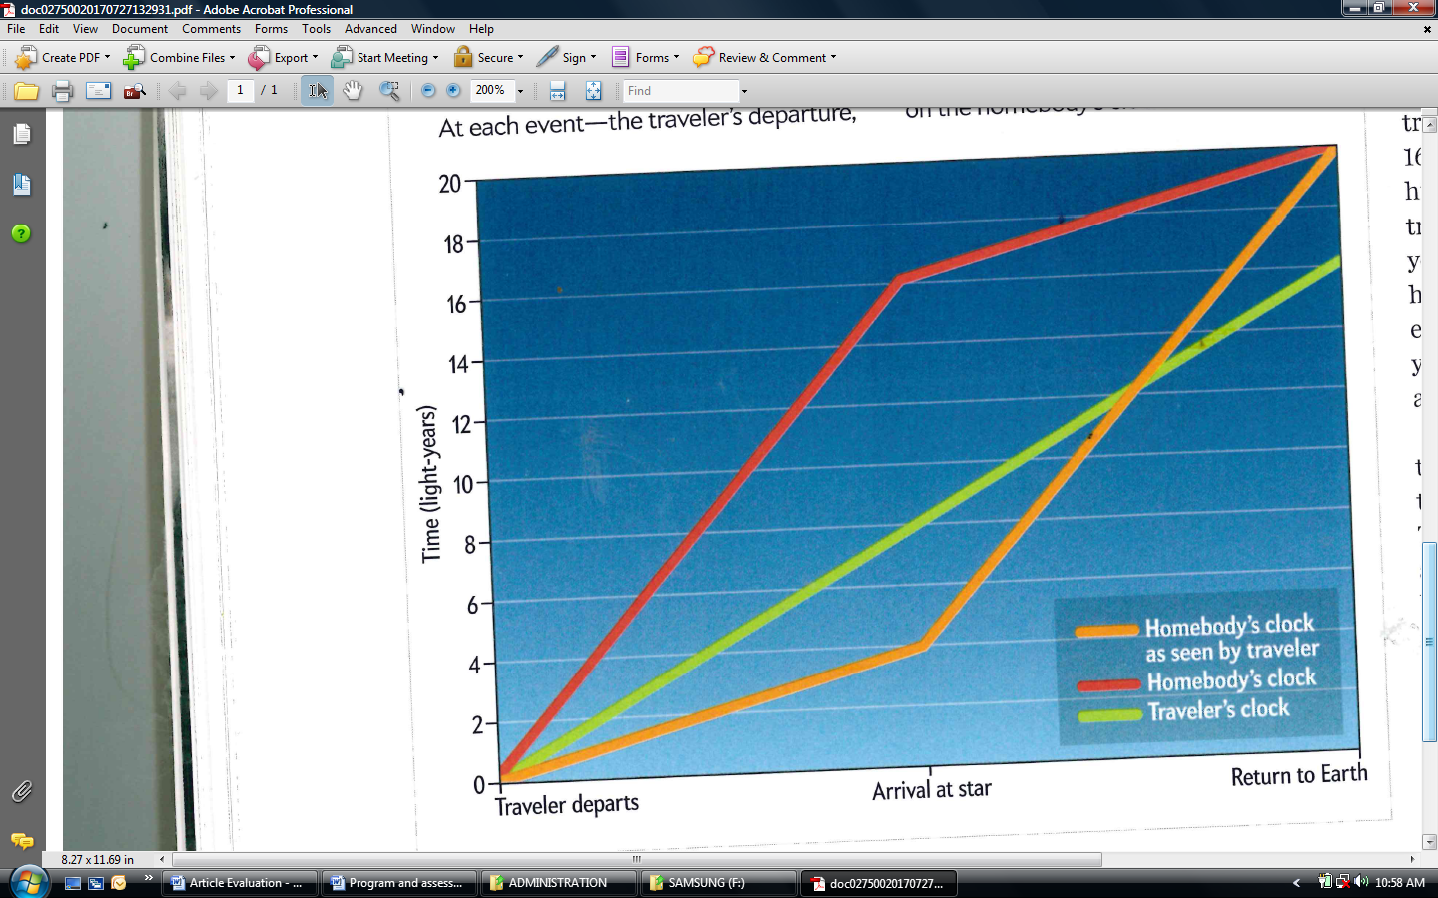3a. In the article above this graph it says “that both the traveller and the homebody see the same reading on the traveller’s clock...” Explain how this can be the case:

i) On arriving at the star

*If the homebody looks through his telescope at the time the traveller arrives at the star, he will see the traveller’s clock as it was then, he will just see it 6 years later. ✓✓*

ii) When the traveller arrives back on Earth

*Back on Earth they can look at the clock together – they will see the same thing. ✓*

*(3 Marks)*

b. i) When the traveller arrives at the star, how many years difference are there between what the traveller and homebody see on the homebody’s clock?

*12 years* *✓*

ii) Explain exactly how this difference in time is accounted for.

Homebody: Takes traveller 10 years by homebody’s clock, plus 6 years for image of him reaching start to arrive, hence 16 years. *✓✓*

Traveller : On homebody’s clock took 10 years to get to star. Traveller sees homebody’s clock as it was 6 years ago, hence 4 years. *✓✓*

Difference between 16 and 4 is 12 years. *✓*

*(6 Marks)*

4. The article very carefully runs the figures for a particular scenario, but does it work for all scenarios? Now you are going to run some of the figures for a different scenario:

Imagine the two twins synchronise watches at 0 years. The traveller then travels at a speed of 0.8c to a star which to an observer on Earth appears to be 10 light years away.

a) How far will the distance to the star appear to the traveller? (ignore acceleration time)

✓

✓

*(2 Marks)*

b) How long has the journey taken from the traveller’s point of view?

✓

✓

*(2 Marks)*

c) How long will the homebody on Earth think the journey should take?

✓

✓

*(2 Marks)*

e) When the homebody sees the traveller arrive at the star, he looks at his own watch. What time does he see?

*12.5+10=22.5 years* ✓

*How long ago light left Star*  ✓

*(2 Marks)*

f) Complete the following tables for the above scenario:

On arrival at star: On return back at Earth:

|  |  |  |  |  |  |  |
| --- | --- | --- | --- | --- | --- | --- |
|  | Homebody Clock (yrs) | Traveller Clock (yrs) |  |  | Homebody Clock (yrs) | Traveller Clock (yrs) |
| Homebody sees | 22.5 | 7.5 |  | Homebody sees | 25 | 15 |
| Traveller sees | 2.5 | 7.5 |  | Traveller sees | 25 | 15 |

✓ ✓ ✓ ✓

*(4 Marks)*

g) Show that the times on return back at Earth consistent with the equation for time dilation, ?

✓

✓

25

*(2 Marks)*

h) The times in the table for arrival at the star are not consistent with the equation for time dilation, ? Does this mean the equation is wrong? Explain.

*No.* ✓*The equation refers to actual time dilation, rather than what is observed on watches* ✓*, where distance from the “other” must be taken into account. The clock you see at a distance is not showing the actual time.* ✓

*(3 Marks)*

5. Consider now this section of the article:

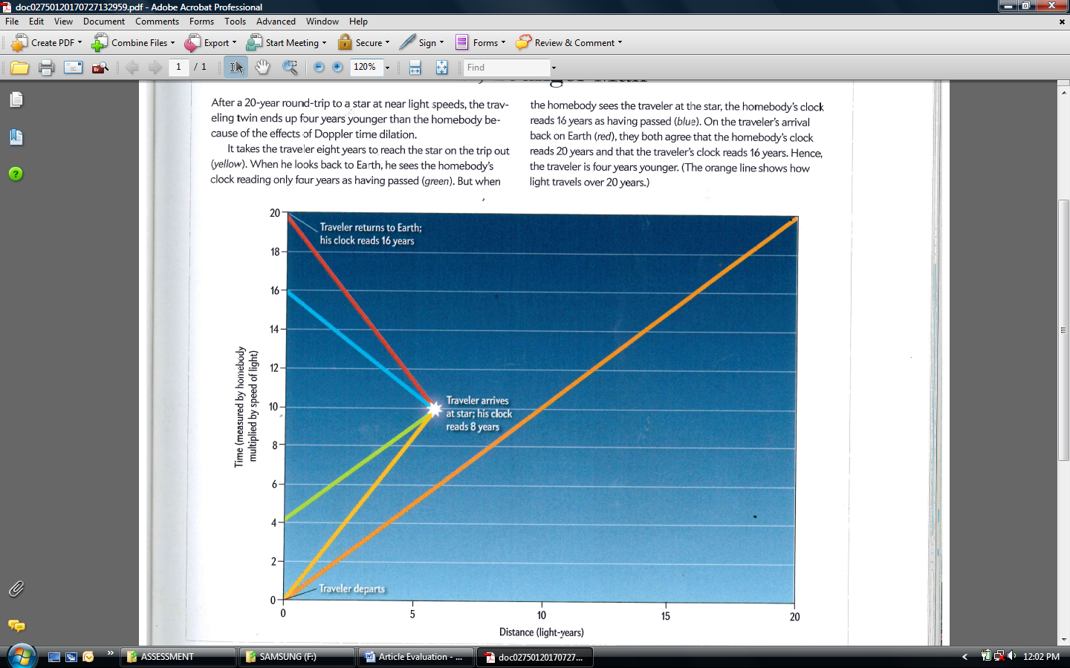

*Green✓*

a) On the graph, label the green line.

*(1 Mark)*

b) Both in this graph and the last, the unit for time on the vertical axis appears to be light-years. What do you understand light-years to be? Explain

*Light-years is usually a measure of distance: ✓*

*1 ly= c1 year ✓*

*(2 Marks)*

c) In general, why might light be required to define time?

*Because the time it takes light to travel 1 light year is fixed. All other time is relative.*

*✓ ✓*

*(2 Marks)*

6. How does relativity effect the lifetime of a muon (page 3)? Explain.

*As the muon is travelling at close to the speed of light, there is significant time dilation.* ✓ *Hence, as measured by the stationary observer the muon appears to have an extended lifetime.* ✓

*(2 Marks)*